# Instructions on how to setup the Emotichair/Vibrochair/ Speakers on Chair thingy~

**MAKE SURE ALL THE POWER CABLES ARE NOT PLUGGED IN UNTIL EVERYTHING IS SET UP**

**MAKE SURE WHEN YOU ARE DONE YOU PUT EVERYTHING BACK WHERE IT BELONGS**

Step 1: The amps in the plywood encasing are already set up and mapped to the correct ports. Just make sure that the yellow wire is in the yellow port, and the blue wire is in the blue port. Refer to the amp inputs picture below.

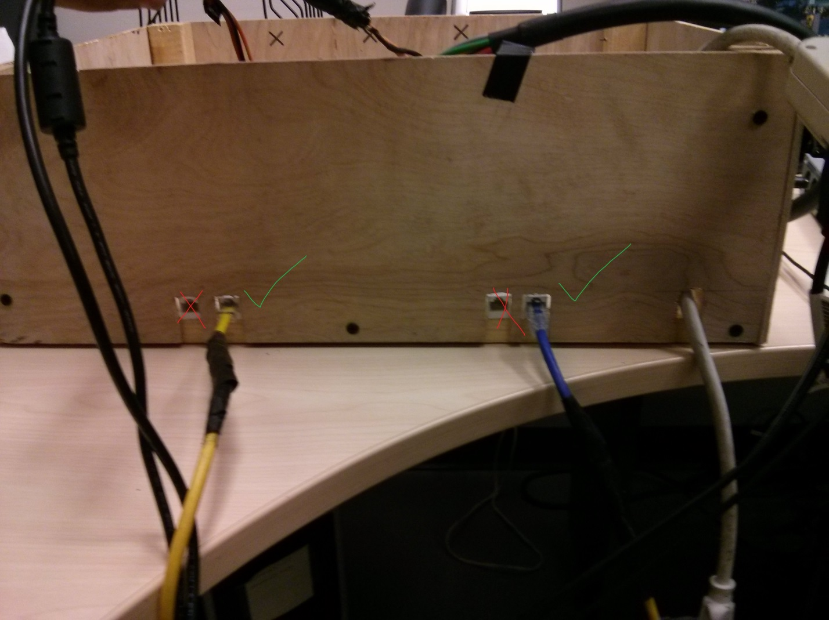

Step 2: Plug the PreSonus FireStudio Audio device to the PC using the FireWire cable. It’s the grey one in the box. Go ahead and plug that in. You know you want to. Then, take the multicolored audio cables and plug it into the back of the ports.

The configuration is as follows:

Channel Input 1: Green Cable

Channel Input 2: Yellow Cable

Channel Input 3: Orange Cable

Channel Input 4: Red Cable

Channel Input 5: Blue Cable

Channel Input 6: Brown Cable

Channel Input 7: Purple Cable

Channel Input 8: Grey Cable

Use the picture below as reference: 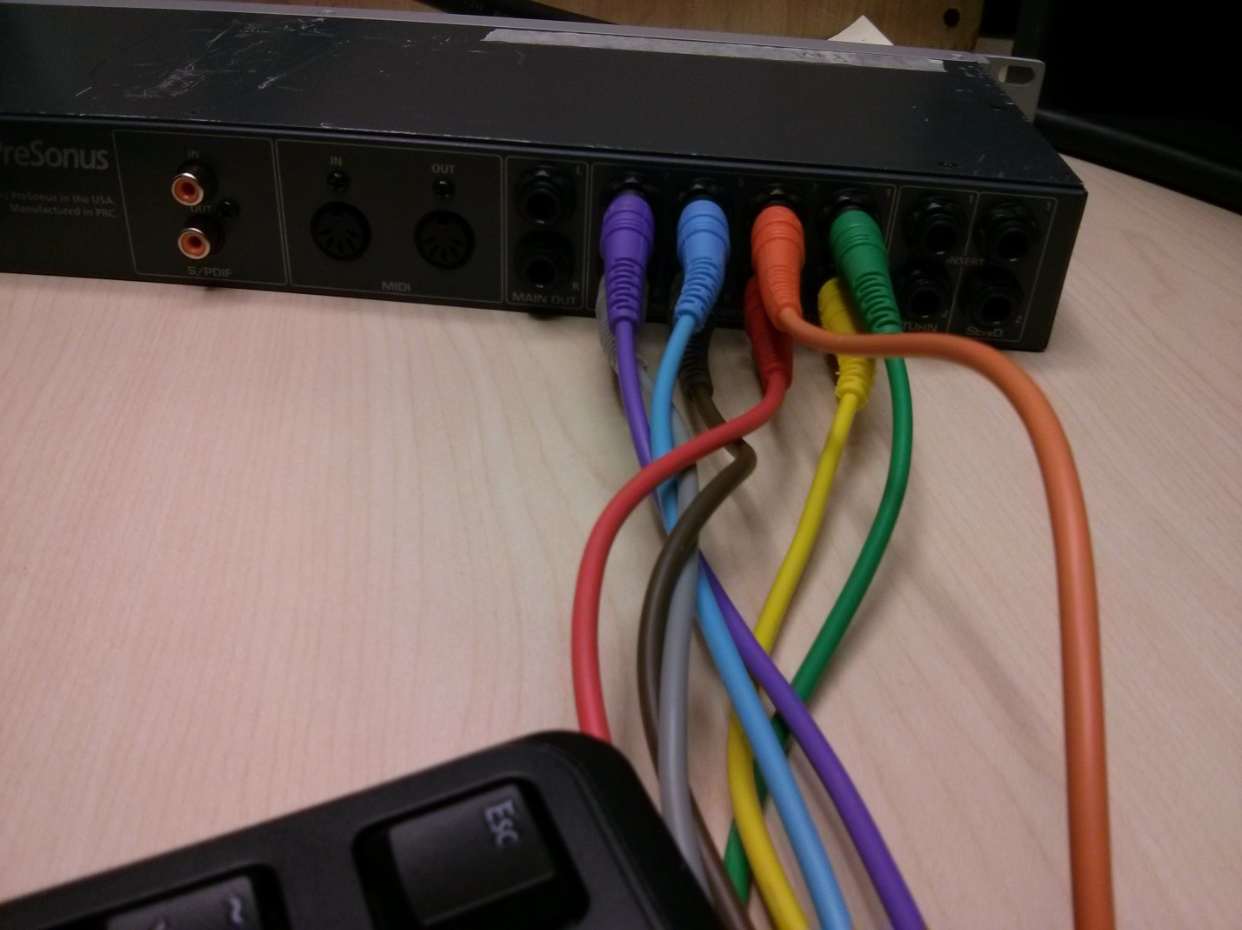

Step 3: Not really a step, but PLEASE NOTE the configuration below when working with applications/software:

Channels 1/2 refer to the Top 4 Speakers

Channels 3/4 refer to the Middle-Top 4 Speakers

Channels 5/6 refer to the Middle-Bottom 4 Speakers

Channels 7/8 refer to the Bottom 4 Speakers

Use the picture below as reference:

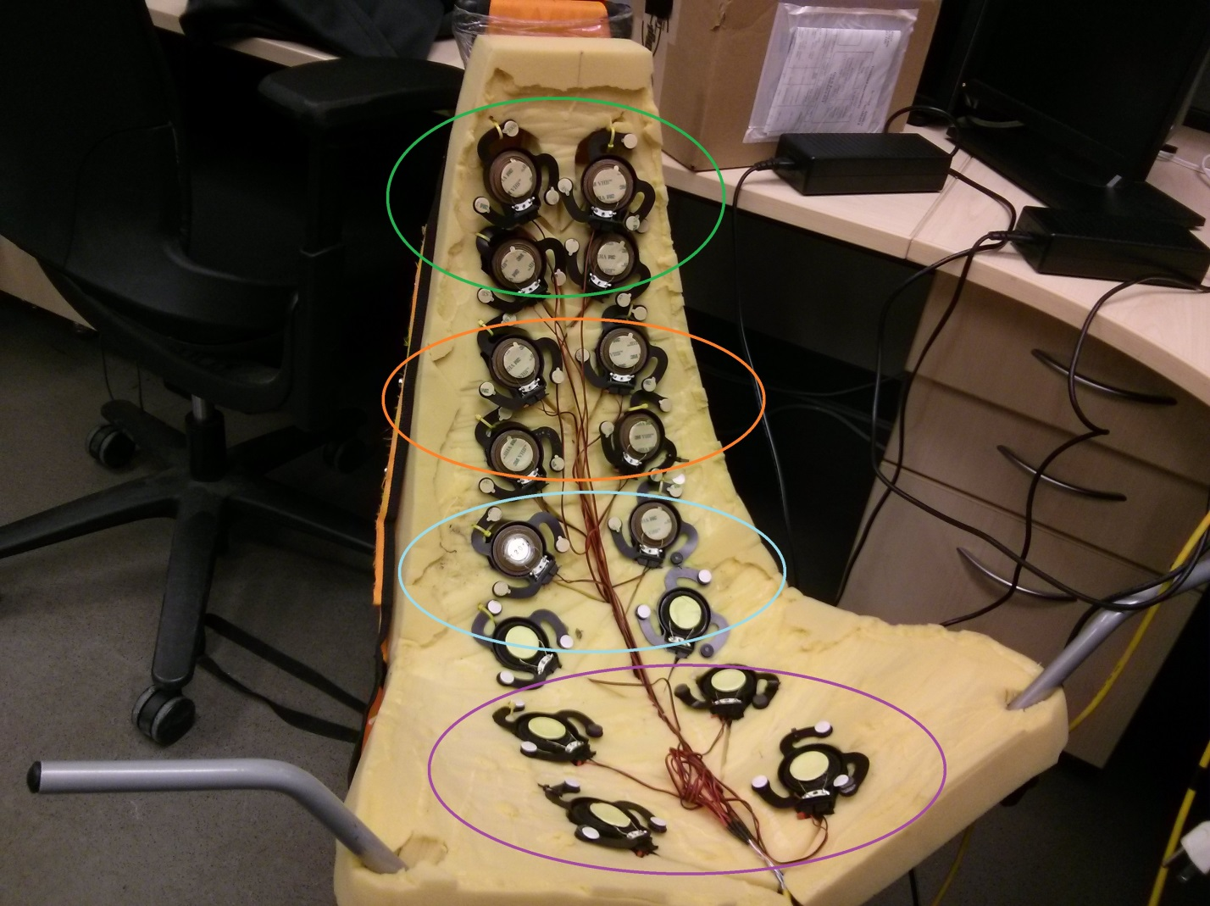

You will need to know this, if you want to output specific sounds or music to each stereo channel (mono still in progress!)

Step 4: Plug in the power adapters for everything. If you hear noise from the chair (you shouldn’t, but if you do…) turn your sounds off on everything, or unplug the amps. Install the drivers for the PreSonus FirePod, as well as the Universal Control. Sorry OSX end-users, you’re gonna have to figure the software side out on your own until I get my hands on one (I’m taking donations guys).

If you successfully installed the drivers, in your sound settings (located in Control Panel\Hardware and Sound\Sound), hit the Playback tab, and make PreSonus FireStudio Audio your default playback device.

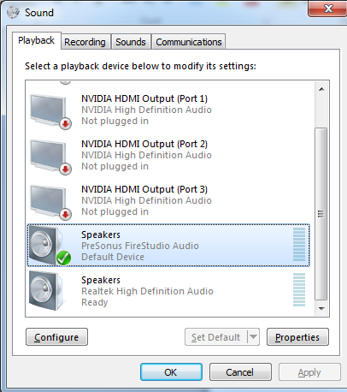

Open up the Universal Control panel (INSTRUCTIONS TO FOLLOW) and make sure each output pairing is as follows:

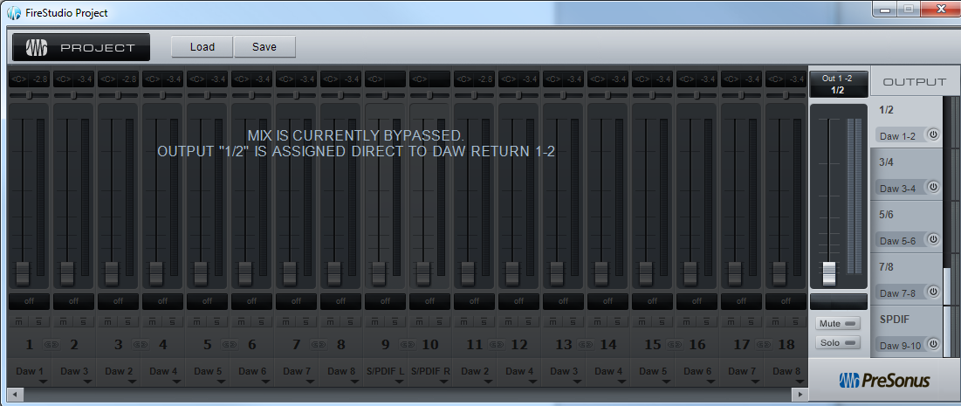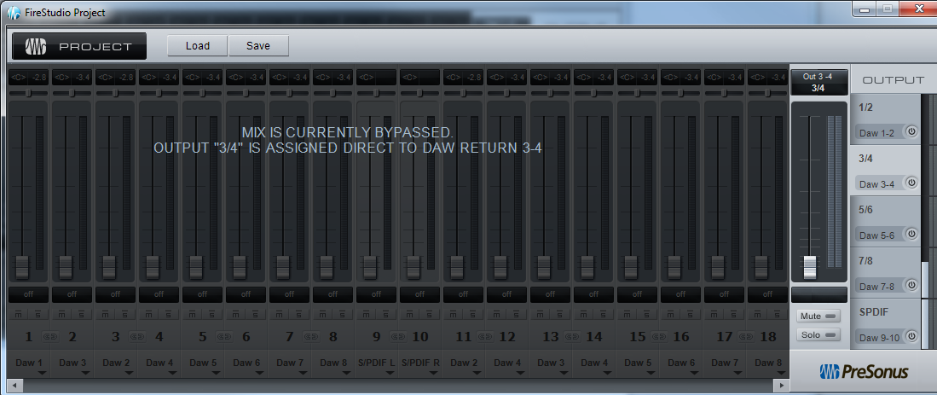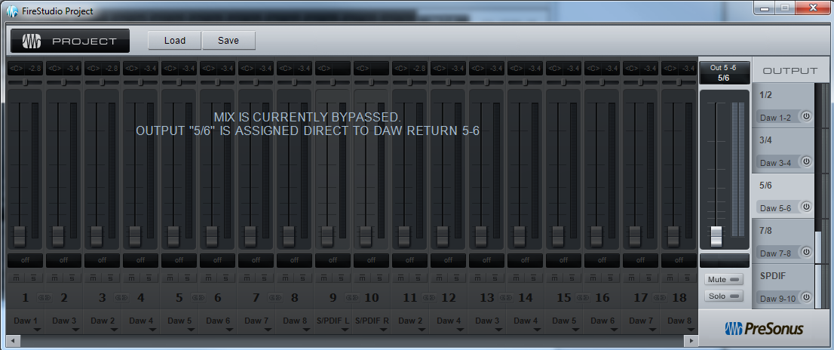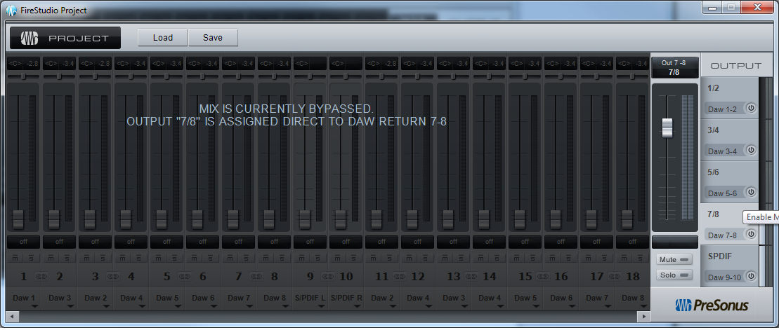

Step 5: That should be it! You should be able to output sound to the four speaker pairings. If you need more help add me on Skype (shah.u.syed) and I’ll get back to you as soon as possible.

**Note: This manual is a work in progress and will eventually be complete as soon as I figure some stuff out (apparently you can save the FireStudio output settings, and the like, and would make setting up even easier).**

Compiled by: Shahnawaz Syed

Special Thanks: Sander & Rener